Calvin Hollingsworth

CIT 230 W04 Website Planning Document

**Website Name:**

“Your Local Weatherman”

Google Domain name: yourlocalweatherman.net

**Motto:** “In this day and age, big storms are a brewin’.”

Site Purpose: To have 24/7 up-to-date information on local weather. Being the first local weather station to inform the public on any changes in weather patterns. People that visit the site will be able to learn more about the current weather and forecast through the website’s media such as: news articles, photos, videos, maps, etc.

**Target Audience:**

#1 Addison: Addison has a potato plantation that her family has owned for 4 generations. She is a bit worried about her crop this year, since the plantation isn’t producing as much potatoes in recent years. The weather has been very harsh which is why she is worried. She is using the website to stay up-to-date on the weather so she can make the preparations needed to protect her farm.

#2 Joey: Since Joey was a little kid, he has been fascinated by the weather. He loves learning about weather in general, but lately has had an interest in the weather of his local area. He is going to school at BYU Idaho to study Earth Science Education. He will to use this site to be updated on the local weather forecast and gain some experience in this field outside of class.

#3 Jocelyn: Jocelyn is an online BYU Idaho student who started school last semester. She is from California and is nervous to be living in Idaho because of the harsh winter weather. She recently moved to Preston to live with her grandparents. She will be using the website to learn more about the local climate and make the preparations needed to live in this area.

#4 Cory: Cory is visiting Idaho for a cross country skiing trip. He will be heading to the Grand Tetons but wants to know what the local weather will be like before he starts his trip. He wants to make sure that he is adequately prepared for this potentially hazardous trip.

#5 Tina: Tina is the mayor of Soda Springs. She was told that a large storm was coming soon that is expected to be a lot stronger than she predicted on another local weather channel. She wants to use this site to double check and confirm if this page will have similar predictions to another weather site that she looked into. She wants to inform the people in her town to prepare for this out of the ordinary storm and most importantly, to be safe.

**Color Scheme:**

I am planning on using Light Blue for my background, Orange for my Title Page and Black for the font colors. I want to use color schemes that are associated with weather and I thought these would be a good fit.

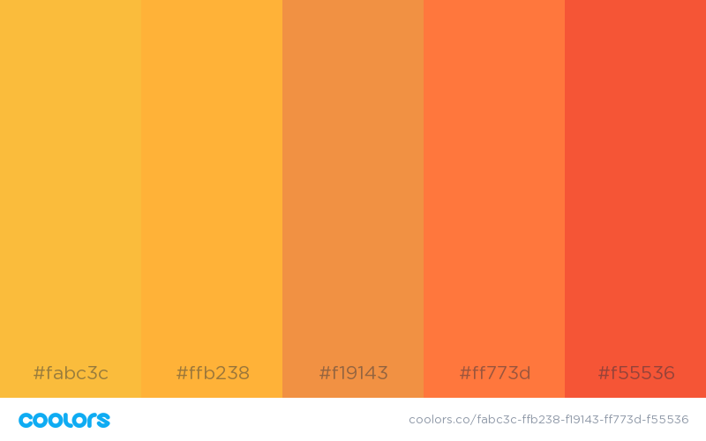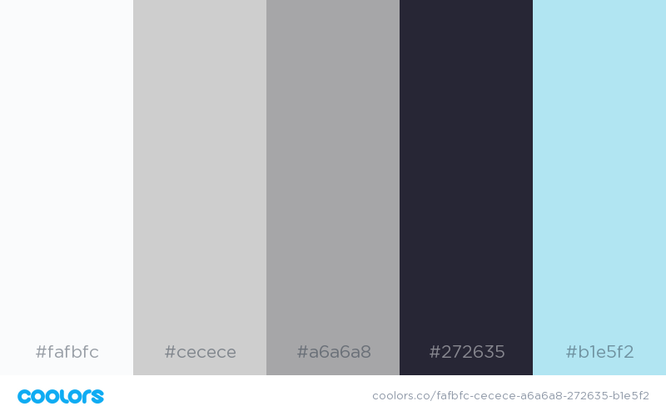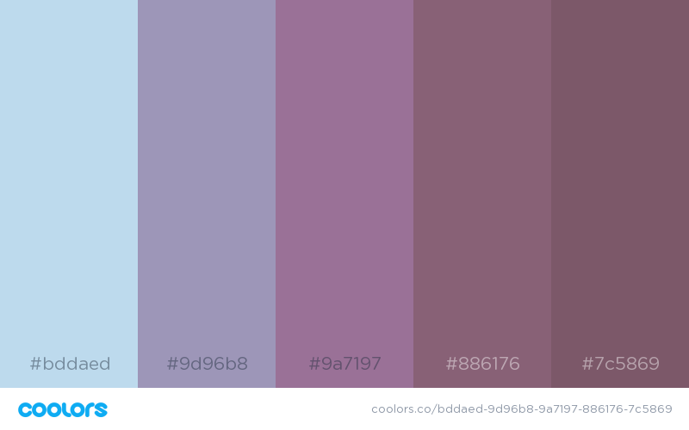

**Typography:**

I am going to use Open Sans for my Google font.

<link href="https://fonts.googleapis.com/css?family=**Open+Sans**" rel="stylesheet">

